
DECRIPTION ON EXAUST FANS | WRITTEN BY:DEHYA KHURRAIM SIDDQUI & SAFDER REHMAN
FANoFAN | CELLING FANS

Table of Contents

HUNTER COBA FRIO ------------------------------------------------------3
HUNTER MARBEL ------------------------------------------------------5
HUNTER VISTA ------------------------------------------------------7
HUNTER SAVOY ------------------------------------------------------9
HUNTER BAYPORT ------------------------------------------------------11
FONTANA MAPLE ------------------------------------------------------13
FONTANA ONE ------------------------------------------------------15
FONTANA ORCHID ------------------------------------------------------17

Figures
Figure 1 3
Figure 2 5
Figure 3 7
Figure 4 9
Figure 5 11
Figure 6 13
Figure 7 15
Figure 8 19

Hunter Cabo Frio

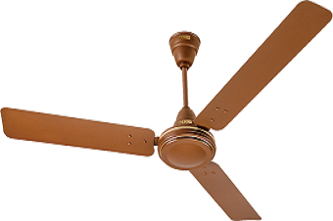
Figure 1
COLOUR: BRONZES SPEED: 190 RPM
SWEEP: 1320mm Power Input: 100 W Air Delivery: 218.5 M³/Min PRICE: RS 20900

KEY FEATURE:

RPM 190 218.5 m³/h 1320 MM

Hunter Maribel
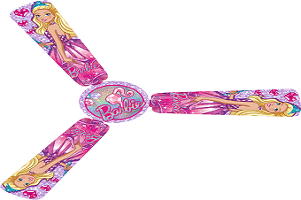
Figure 2
COLOUR: PINK SPEED: 224 RPM
SWEEP: 1320 mm Power Input: 100 W
Air Delivery: 245.9 M³/Min PRICE: RS 18990

KEY FEATURE:
RPM 224 245.9 m³/h 1320MM

Hunter Vista

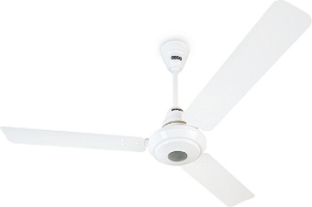
Figure 3
COLOUR: GREY SPEED: 210 RPM
SWEEP: 1320 mm Power Input: 100 W
Air Delivery: 255 M³/Min PRICE: RS 15599

KEY FEATURE:
RPM 210 255 m³/h 1320MM

Hunter Savoy

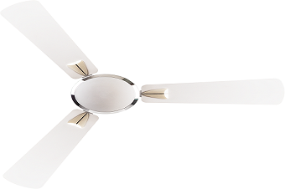
Figure 4
COLOUR: WHITE SPEED: 200 RPM
SWEEP: 1320 mm Power Input: 100 W
Air Delivery: 255 M³/Min PRICE: RS 14999

KEY FEATURE:
RPM 200 255 m³/h 1320MM

Hunter Bayport

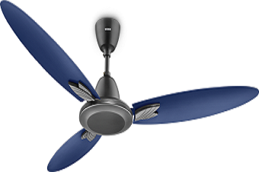
Figure 5
COLOUR: NAVY BLUE SPEED: 255 RPM
SWEEP: 1067mm Power Input: 80W
Air Delivery: 210 M³/Min PRICE: RS 12599

KEY FEATURE:
RPM 255 210 m³/h 1067MM

Fontana Maple

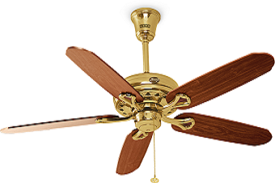
Figure 6
COLOUR: WOODEN SPEED: 310 RPM
SWEEP: 1250mm Power Input: 70 W
Air Delivery: 205M³/Min PRICE: RS 8100

KEY FEATURE:
RPM 310 205 m³/h 1250MM

Fontana One
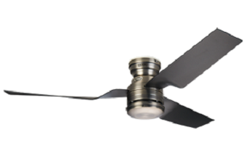
Figure 7
COLOUR: SHINY BLACK SPEED: 2300 RPM
SWEEP: 1270 mm Power Input: 70 W
Air Delivery: 205 M³/Min PRICE: RS 8100

KEY FEATURE:
RPM 2300 205 m³/h 1270MM

Fontana Lotus

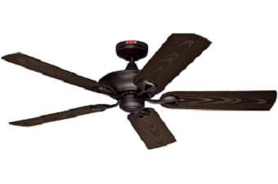
Figure 8
COLOUR: CHOCOLATE SPEED: 310 RPM
SWEEP: 1230 mm Power Input: 70 W
Air Delivery: 205 M³/Min PRICE: RS 7500

KEY FEATURE:
RPM 310 205 m³/h 1230MM

WRITTEN BY

DEHYA KHURRAIM SIDDQUI : WEB DESIGNER
SAFDER REHMAN : WEB EDITOR

IN SUPPERVISION OF

MISS ALMAS.

WEBSITE LINK

